ALL ABOARD! Come join us for a ride on the Brightline to miami museums.
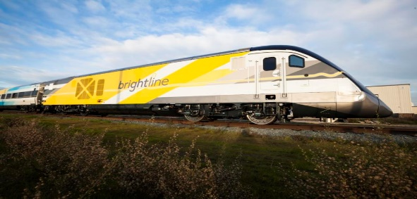
This Photo by Unknown Author is licensed under CC BY-NC-ND

Who: Harbourside residents
What: Day trip on the Brightline to Miami Perez Museum of
Art or the Frost Museum of Science; both are in
the Downtown Miami Museum Park) via Brightline.
We will board the 10:30 am train at the West Palm
Beach station, lunch at the 4 star Verde Restaurant
overlooking Biscayne Bay, return on the 5: 40 train
to WPB.
Where: Cars will leave promptly at 9:10 am from clubhouse
entrance & return at approximately 7:30 pm.

When: Friday, February 22
Cost: $64 per person ($70 if you are not yet 65) for
Brightline tickets due to Trish in Harbourside
Management Office by February 6. Cash or check payable to Kathy Baldwin. Please sign sheet in office with your name & phone #. (You will also need to take money to pay for museum entry and lunch.)

Sponsored by your Harbourside Social Committee

